ABSTRACT

Cardiovascular diseases (CVDs) remain a leading cause of global morbidity and mortality. Early detection and intervention are crucial for improving patient outcomes and reducing the burden on healthcare systems. Recent research suggests a potential link between retinal vascular changes and cardiovascular health. Retinal images offer a non-invasive means to assess microvascular abnormalities, making them an attractive source of data for predictive modeling. This project focuses on developing a machine learning model, specifically using Recurrent Neural Networks (RNNs), to analyze retinal images and detect patterns indicative of heart diseases. RNNs are well-suited for processing sequential data, making them suitable for capturing temporal dependencies in the retinal images and improving the predictive accuracy of the model.

Chapter 1
INTRODUCTION

1.1 Overview of the project:
Heart disease, also known as cardiovascular disease, refers to a class of diseases that involve the heart or blood vessels. It is a broad term encompassing various conditions that affect the cardiovascular system. The most common type of heart disease is coronary artery disease, which can lead to heart attacks.
This machine learning project aims to leverage Recurrent Neural Networks (RNNs) for the detection of heart diseases through the analysis of retinal images. The utilization of retinal images as a diagnostic tool has gained attention due to the potential correlation between retinal characteristics and cardiovascular health. The retina, as a neural tissue, shares vascular similarities with the cardiovascular system, and abnormalities in retinal vessels may indicate underlying heart conditions. The retina, located at the back of the eye, shares vascular similarities with the cardiovascular system. Abnormalities in the retinal blood vessels or microvascular changes may reflect systemic vascular health, including conditions related to the heart.
1.1 Project Description
Recurrent Neural Networks (RNNs) are a class of artificial neural networks designed to handle sequential data and capture patterns over time. Unlike traditional neural networks, RNNs have connections that create cycles within the network, allowing them to maintain a memory of previous inputs. By employing RNNs, which excel in handling sequential data, this project seeks to enhance the accuracy and efficiency of heart disease detection, contributing to early diagnosis and timely intervention. This project holds significance in the realm of healthcare by providing a non-invasive and potentially cost-effective method for early heart disease detection. If successful, the utilization of retinal images as a diagnostic tool could offer a proactive approach to cardiovascular health assessment. The aim of this project is to develop an accurate and efficient heart disease detection system using Recurrent Neural Networks (RNNs) to analyze retinal images. By leveraging the sequential data handling capabilities of RNNs, the project seeks to identify patterns and abnormalities in retinal vessels that correlate with cardiovascular conditions. This non-invasive approach aims to contribute to early diagnosis and timely intervention in heart disease, offering a proactive and potentially cost-effective method for assessing cardiovascular health through retinal imaging.
Traditional methods of diagnosing heart diseases often rely on clinical parameters and expensive diagnostic tests. The lack of a non-invasive, cost-effective, and early screening tool poses challenges in timely disease detection. Retinal images, with their potential to reflect microvascular changes associated with cardiovascular conditions, present an opportunity to address this gap.

The challenge lies in developing a robust machine learning model that can effectively analyze retinal images and identify subtle patterns indicative of underlying heart diseases. Furthermore, addressing issues such as data variability, image quality, and interpretability is crucial for the model's clinical applicability.
The project has the following applications
- Healthcare professionals could use the developed model as an auxiliary tool for early detection and screening of heart diseases during routine eye examinations.
- The project could be integrated into telemedicine platforms, allowing for remote monitoring of patients' cardiovascular health through retinal images captured using portable devices or smartphones.
- General practitioners and primary care physicians could benefit from the model as a supplementary diagnostic tool.
- The project could be utilized in public health campaigns aimed at increasing awareness and promoting early detection of heart diseases.

1.2 Company Profile

Chapter 2

LITERATURE REVIEW

2.1 Existing System:

Traditional methods of detecting heart disease typically involve a combination of clinical assessment, medical history, physical examination, and various diagnostic tests. Healthcare professionals collect information about a patient's medical history, lifestyle, symptoms, and risk factors for heart disease. A thorough physical examination helps identify signs such as abnormal heart sounds (murmurs) or irregularities in the pulse. An ECG measures the electrical activity of the heart and can help identify irregularities in heart rhythm (arrhythmias), signs of a previous heart attack, and other cardiac abnormalities. Blood tests may be conducted to measure levels of cholesterol, triglycerides, and other lipids. Elevated levels of cholesterol and triglycerides can contribute to atherosclerosis, a major precursor to heart disease.
Disadvantages of Existing System:

- Existing methods may lack the sensitivity to detect early stages of heart disease or subtle abnormalities, leading to delayed diagnosis.

- Certain diagnostic tests, such as cardiac catheterization and angiography, involve invasive procedures that carry inherent risks and can cause discomfort to patients.

- Interpretation of certain tests, such as stress testing or ECG, can be subjective and dependent on the skills and experience of the healthcare professional. This subjectivity may lead to variability in diagnoses.
Proposed System:

Recurrent Neural Networks (RNNs) are a type of artificial neural network designed to handle sequential data. Unlike traditional feedforward neural networks, RNNs have connections that form cycles, allowing them to maintain a memory of previous inputs. This memory mechanism enables RNNs to process sequences of data, making them suitable for tasks such as time series prediction, natural language processing, and the analysis of sequential image data like retinal images. Using Recurrent Neural Networks (RNNs) with retinal image datasets involves leveraging the sequential nature of image data, particularly when dealing with temporal or spatial sequences within images. While RNNs are traditionally associated with sequential data like time series, they can be adapted for image datasets by treating the image as a sequence of pixels or by incorporating temporal dependencies.

Advantages of Proposed System:
- RNNs provide a framework for contextual understanding of retinal images. By considering the sequential nature of pixel data, the model can interpret the significance of each pixel in relation to its context, facilitating the identification of subtle patterns and abnormalities.

- RNNs can adapt to variable image sizes, making them suitable for retinal image datasets with diverse resolutions. This adaptability allows the model to handle images from different sources and imaging devices without requiring a fixed input size.

- RNNs can automate the process of pattern recognition within retinal images, potentially reducing the need for manual interpretation. This automation enhances efficiency in large-scale screening and analysis tasks.

- Heart diseases often involve long-term physiological changes. RNNs, with their ability to capture long-term dependencies, can potentially identify subtle and gradual alterations in retinal features that may correspond to the development of cardiovascular issues.

2.2 Feasibility Study

Feasibility study is a procedure that identifies, describes and evaluates application. An estimate is made whether the identified users need may be satisfied using the current networking facilities and hardware technologies. The study will decide whether the proposed application will be cost effective from a business point of view and if it can be developed using the given existing budgetary constraints.

The key considerations involved in the feasibility analysis of our proposed application are the following:
- Operational Feasibility
- Technical Feasibility
- Economic Feasibility
- Schedule Feasibility

Operational Feasibility

Operational feasibility is necessary as it ensures that the project developed is a successful one.The operational feasibility of this project is high since it is user friendly and the application provides all the expected outputs to the user.

Technical Feasibility

Technical feasibility analysis makes a comparison between the level of technology available and that is needed for the development of the project. The level of technology consists of the factors like software tools, and platform developed and so on. Since, the resources for the development of the project is available, the project is technically feasible.

Economic Feasibility

This is the most important part of the project because the terms and conditions for implementing the project have to be economically feasible. The risk of finance does not exist as the existing hardware that is smart phone is sufficient and the software is free of cost. So, it is believed that the system is economically feasible.

Schedule Feasibility
Schedule feasibility is defined as the likelihood of a project being completed within its desired timeframe. Since this project has a high likelihood of completion by the desired due date, schedule feasibility is considered to be high.

2.3 Tools and Technologies Used

HTML (Hypertext Markup Language): HTML is the standard markup language for creating the structure and content of web pages.

CSS (Cascading Style Sheets): CSS is used to define the visual presentation and layout of HTML elements in a web page.

Flask: Flask is a lightweight web framework for Python that provides a simple and efficient way to build web applications. It allows developers to create routes, handle requests, and manage application logic.

Python: Python is widely regarded as one of the most popular programming languages for machine learning due to its simplicity, versatility, and an extensive ecosystem of libraries and frameworks.

MySQL: MySQL is a popular relational database management system (RDBMS). It offers efficient data storage and retrieval capabilities and can be integrated with Python using libraries such as pymysql or MySQL Connector.

Integrated Development Environment (IDE): An IDE is a software tool that provides an integrated environment for coding, debugging, and testing applications. Python IDLE is used for development.

Machine Learning

Machine learning is a field of study where computer algorithms are designed to enable computers to learn and make predictions or decisions without being explicitly programmed for each task. It involves training computers to learn from examples and experiences, allowing them to automatically identify patterns and make accurate predictions based on data.

To accomplish this, large amounts of data are fed into the computer, along with algorithms or rules that enable it to analyze and learn from the data. Through this process, the computer becomes adept at recognizing patterns, establishing relationships, and making predictions or taking actions when presented with new or unfamiliar data. Essentially, it is akin to teaching a computer to recognize patterns and make predictions by exposing it to numerous examples.

Machine learning finds application in various aspects of our daily lives, including voice recognition, image classification, recommendation systems, fraud detection, and even self-driving cars. Its potential lies in automating tasks, enhancing decision-making processes, and improving overall efficiency. By harnessing the power of machine learning, computers are empowered to learn from data, continually improve their performance, and assist us in solving intricate problems and making informed decisions.

Python Language

Python has emerged as one of the most favored programming languages for machine learning due to its extensive range of libraries and frameworks tailored specifically for this field. Python offers a multitude of tools and resources that greatly simplify the implementation of machine learning algorithms and workflows.
Python's machine learning ecosystem boasts several key features:
1. Libraries and Frameworks: Python provides an array of powerful libraries and frameworks dedicated to machine learning. Notably, scikit-learn offers a comprehensive suite of tools for data preprocessing, feature selection, model training, and evaluation. TensorFlow, developed by Google, specializes in deep learning and neural networks. Other popular frameworks like PyTorch, Keras, and MXNet facilitate the creation and training of machine learning models.
2. Data Manipulation and Analysis: Python offers libraries such as NumPy and pandas, which are vital for data handling and manipulation in machine learning tasks. NumPy enables efficient numerical operations and array manipulation, while pandas provides data structures and functions for comprehensive data analysis and manipulation. These libraries streamline data preprocessing and transformation prior to feeding it into machine learning algorithms.
3. Visualization and Plotting: Python's visualization libraries, such as Matplotlib and Seaborn, empower users to create impactful visualizations and plots. These tools facilitate gaining insights from data and assessing model performance. Matplotlib and Seaborn encompass a wide range of chart types and graphs, enabling users to discern patterns and trends within the data more effectively.
4. Community and Resources: Python boasts a vibrant community of machine learning practitioners, researchers, and enthusiasts. This active community continuously produces a wealth of resources, including tutorials, documentation, and code examples. These invaluable resources aid in learning and implementing machine learning algorithms in Python, and the collaborative nature of the community encourages the sharing of best practices and the continuous enhancement of the ecosystem.
5. Integration with Other Technologies: Python seamlessly integrates with other technologies commonly employed in machine learning. It can be combined with SQL databases for efficient data storage and retrieval, Apache Spark for distributed data processing, or web frameworks like Flask and Django for deploying machine learning models as web services.
In summary, Python's extensive range of libraries, frameworks, and the supportive community make it an excellent choice for machine learning tasks. Its user-friendly syntax simplifies model development and deployment, while its robust data manipulation, analysis, and visualization capabilities enhance the overall machine learning workflow.

Python IDLE

Python IDLE (Integrated Development and Learning Environment) is an integrated development environment (IDE) bundled with Python. It offers a user-friendly interface for writing, running, and testing Python code, making it ideal for beginners.

Python IDLE provides several notable features:

Editor: Python IDLE includes a built-in text editor that supports syntax highlighting, indentation assistance, and auto-completion. These features enhance code writing by reducing errors and improving productivity.

Interactive Shell: The interactive shell is a standout feature of Python IDLE. It allows you to execute Python code line by line, providing immediate feedback on the output. This feature is helpful for experimenting, testing code snippets, and exploring Python interactively.

Debugger: Python IDLE incorporates a debugger tool that aids in identifying and resolving errors or bugs in code. It enables you to step through the code, set breakpoints, and examine variable values during execution, facilitating troubleshooting and understanding of program flow.

Code Execution: Python IDLE allows you to run your code directly from the editor or the interactive shell. It offers options to execute the entire script or specific portions, simplifying testing and debugging processes.

Help and Documentation: Python IDLE provides access to extensive documentation and help resources. It offers context-sensitive help, allowing users to access relevant documentation for Python language features, libraries, and functions. It also provides browsing capabilities for official Python documentation.

Python IDLE serves as a lightweight and beginner-friendly IDE, enabling users to write, execute, and explore Python code. It offers a simple interface with useful features for coding, debugging, and learning Python programming. While it may lack advanced functionalities found in other IDEs, Python IDLE remains a convenient choice for beginners and basic coding tasks.

Flask Web kit Framework

Flask is a widely used Python web framework known for its simplicity and flexibility. It enables developers to swiftly and effectively construct web applications. Flask adheres to the Model-View-Controller (MVC) architectural pattern and offers a plethora of tools and libraries to handle diverse web development tasks.

The framework provides essential features such as URL routing, template rendering, request management, session handling, and database integration. Its minimalistic design empowers developers to selectively incorporate and combine components based on their specific project requirements. Flask boasts an active community and comprehensive documentation, making it a favored option for creating web applications of varying sizes and complexities.

2.4 HARDWARE AND SOFTWARE REQUIREMENTS

Hardware Requirements:

- Processor: Intel Core i3 or higher
- RAM: 8GB or higher
- Storage: 10GB or higher
Software Requirements:

- Operating System: Windows 10
- Frontend: HTML, CSS, Flask Web kit Framework
- Backend: Python 3.6 or higher
- Database: MySQL

CHAPTER -3
SOFTWARE REQUIREMENT SPECIFICATION

3.1 Users
In this heart disease detection system, users play a crucial role in the testing phase of the application. Users are the main beneficiaries of the system. They begin by registering with their details, ensuring that the system maintains a secure and personalized experience. After successful registration and login, users can input test images of retinal scans into the system. The trained Recurrent Neural Network (RNN) model then analyzes these images to detect any abnormalities in retinal vessels that may indicate a risk of heart disease. This provides users with a non-invasive, efficient, and potentially cost-effective method to assess cardiovascular health, enabling early diagnosis and timely intervention.
Additionally, the system can be integrated into telemedicine platforms, allowing for remote monitoring of patients' cardiovascular health through retinal images captured using portable devices or smartphones. This capability is particularly beneficial for patients in remote or underserved areas, where access to specialized cardiovascular diagnostics is limited. Public health campaigns can also leverage the system to promote early detection and awareness of heart diseases, encouraging more individuals to undergo routine screenings during eye examinations. By utilizing this innovative approach, users can significantly enhance their diagnostic capabilities and contribute to better cardiovascular health outcomes.

3.2 Functional Requirements
- Admin:

Admin has the responsibility of overseeing the training phase of the application. Once logged in successfully, Admin can upload the training dataset, initiate the training process using the ML algorithm, create a model, and view the training results.

Features

  - Login
  - Upload Dataset
  - Train
  - Save Model
  - View Performance

- User:
The User has the responsibility of overseeing the testing phase of the application. He has to first register with his details. After successful login, he can input test image and check whether there is risk of heart attack or not.
Features

- Register
- Login
- Input Test Image
- View Prediction
3.3 Non Functional Requirements

Non-functional requirements for this project would encompass various aspects related to system performance, reliability, security, usability, and scalability. Here are some non-functional requirements that should be considered:

Performance:
The system should be capable of processing a large volume of retinal images efficiently to ensure timely diagnosis. The processing time per image should be within acceptable limits to maintain user satisfaction and minimize waiting times.The accuracy of the detection algorithm should meet or exceed industry standards.

Scalability:
The system should be designed to accommodate an increasing number of users and images without significant degradation in performance.

Reliability:
The system should exhibit high reliability to ensure consistent performance under normal operating conditions. It should be resilient to potential failures, such as hardware malfunctions or network outages, to minimize downtime and data loss.
Usability:
The user interface should be intuitive and easy to navigate.

Chapter 4

SYSTEM DESIGN

The design document that we develop during this phase is the blueprint of the software. It describes how the solution to the customer problem is to be built. The design activity begins when the requirements document for the software to be developed is available. While the requirements specification activity is entirely in the problem domain, design is the first step in moving from the problem domain toward the solution domain. Design is essentially the bridge between requirements specification and the final solution for satisfying the requirements.

The design of a system is essentially a blueprint or a plan for a solution for the system. The design process for software systems, often, has two levels. At the first level, the focus is on deciding which modules are needed for the system, the specifications of these modules, and how the modules should be interconnected. This is what is called the system design or top-level design. In the second level, the internal design of the modules, or how the specifications of the module can be satisfied, is decided. This design level is often called detailed design or logic design. Detailed design essentially expands the system design to contain a more detailed description of the processing logic and data structures so that the design is sufficiently complete for coding.

4.1 System Architecture
A system architecture is the conceptual model that defines the structure, behavior, and more views of a system. An architecture description is a formal description and representation of a system, organized in a way that supports reasoning about the structures and behaviors of the system.

Architectural design
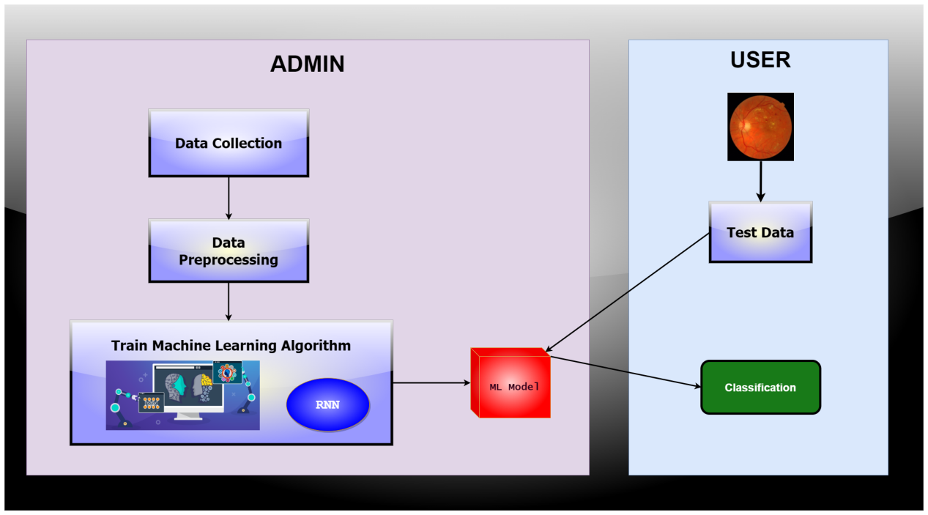

Chapter 5

DETAILED DESIGN

5.1 Use Case Diagram:
A use case diagram in the Unified Modeling Language (UML) is a type of behavioral diagram defined by and created from a Use-case analysis. Its purpose is to present a graphical overview of the functionality provided by a system in terms of actors, their goals (represented as use cases), and any dependencies between those use cases. The main purpose of a use case diagram is to show what system functions are performed for which actor. Roles of the actors in the system can be depicted.

Usecase – Admin

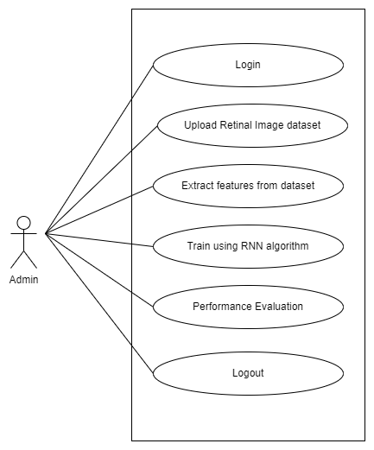

Usecase – User

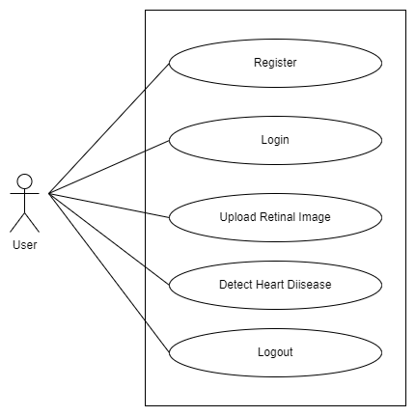

4.3 Sequence Diagram:
A sequence diagram in Unified Modeling Language (UML) is a kind of interaction diagram that shows how processes operate with one another and in what order. It is a construct of a Message Sequence Chart. Sequence diagrams are sometimes called event diagrams, event scenarios, and timing diagrams.
Sequence – Admin
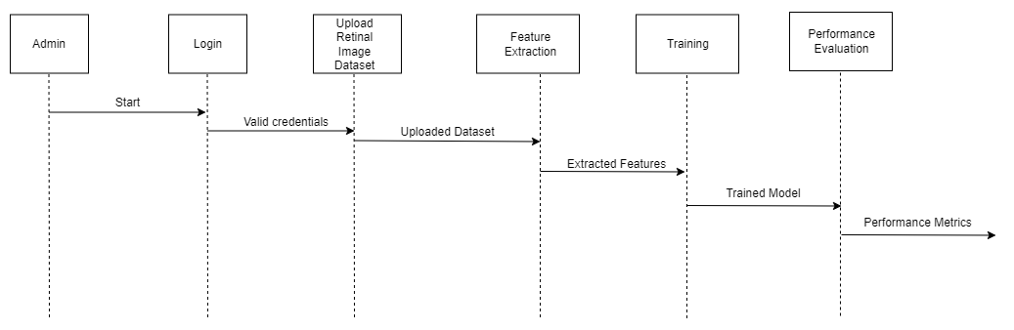

Sequence – User
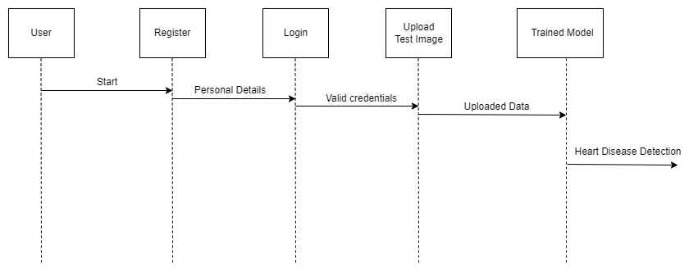

4.4 ACTIVITY DIAGRAM:
Activity diagrams are graphical representations of workflows of stepwise activities and actions with support for choice, iteration and concurrency. In the Unified Modeling Language, activity diagrams can be used to describe the business and operational step-by-step workflows of components in a system. An activity diagram shows the overall flow of control.

Activity Diagram – Admin

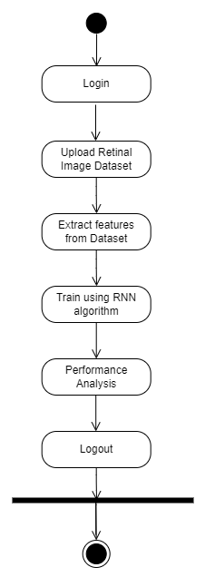

Activity Diagram – User
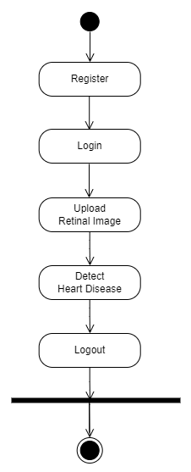

Chapter 5

IMPLEMENTATION

Algorithm – RNN:
In the context of detecting heart diseases using retinal images, Recurrent Neural Networks (RNNs) are pivotal for analyzing sequential data, such as the vascular patterns present in the retina. RNNs, equipped with memory mechanisms, can capture dependencies over time, enabling them to recognize subtle changes in retinal features indicative of cardiovascular health. By leveraging Long Short-Term Memory (LSTM) cells to address long-term dependencies, RNNs extract meaningful features from retinal sequences, facilitating the identification of abnormalities associated with heart diseases. Through iterative training and optimization, the RNN learns to map retinal images to disease labels, contributing to the integration of diagnostic systems for early detection and intervention. In essence, RNNs play a critical role in enhancing the accuracy and efficiency of heart disease detection from retinal images, paving the way for proactive management of cardiovascular health.

Dataset:

The dataset used in this project consists of retinal images categorized into different risk levels associated with diabetic retinopathy (DR) and other cardiovascular conditions. Diabetic retinopathy is a common complication of diabetes and is characterized by damage to the blood vessels in the retina. The dataset includes images representing various stages of DR, ranging from mild to severe, as well as images indicating the absence of DR. Additionally, the dataset may contain images representing proliferative diabetic retinopathy (PDR), the most advanced stage of DR characterized by the growth of abnormal blood vessels in the retina. Each retinal image in the dataset is annotated with its corresponding risk category, allowing for supervised learning algorithms to be trained for heart disease detection. This diverse dataset enables the development and evaluation of machine learning models aimed at leveraging retinal images for early detection and classification of heart diseases, providing valuable insights into the relationship between retinal characteristics and cardiovascular health.

Proposed Methodology:
- Data Collection:
Collect a diverse and representative dataset of retinal images from individuals with varying cardiovascular health statuses. Ensure the dataset represents different demographics, ages, and risk factors. Annotations indicating whether each individual has a known cardiovascular condition or is healthy should be included.
- Data Preprocessing:
Preprocess the data to ensure uniformity and remove irrelevant information. Ensure uniformity in the dataset by standardizing the resolution, color channels, or any other relevant parameters of the retinal images. Remove irrelevant information or artifacts that may not contribute to the heart disease detection task. This step may involve noise reduction, image cropping, or masking.
3. Model Development:
Design and implement an RNN-based architecture suitable for processing sequential retinal image data. Train the RNN-based model on the prepared dataset. During training, the model learns to recognize patterns and relationships within the sequential retinal images and their corresponding labels. Optimize the model for sensitivity and specificity. Sensitivity ensures the model can detect true positives, while specificity minimizes false positives.
4. Model Evaluation and Validation:
Assess the performance of the developed model using relevant metrics. Validate the model on independent datasets to ensure generalizability. Evaluate the model using metrics such as accuracy.
5. Testing and deployment:
Use the testing dataset to evaluate the final performance of the trained model on unseen data. Once satisfied with the model's performance, it can be deployed to make predictions on new retinal images and detect heart disease.

The proposed system will be developed using Python and Flask, a web application framework. Flask is a lightweight and modular web application framework for Python. It is known for its simplicity, making it a popular choice for developing small to medium-sized web applications. Flask provides the necessary tools for routing, templating, and handling HTTP requests.
By following this proposed methodology, the aim is to develop a robust RNN-based model for heart disease detection using retinal images, ensuring data quality and model performance are prioritized throughout the process.
- https://doi.org/10.1016/J.MATPR.2020.09.078
Python Installation:
Download Python Installer:
  - Visit python.org and navigate to the downloads section.
  - Choose Python version 3.10 (or the version you prefer).
  - Select the installer suitable for your operating system (Windows, macOS, Linux).
Run the Installer:

  - Once the installer is downloaded, locate the executable file (.exe for Windows).
  - Double-click the installer to begin the installation process.

Installation Steps:

  - In the Python installer, you will be prompted with several options.
  - Select "Install Now" to use the default settings.
  - Optionally, you can customize the installation by clicking on "Customize installation".

Add Python to PATH:

  - During the installation process, ensure to check the box that says "Add Python to PATH".
  - This step is crucial for easily running Python scripts from the command line.

Complete the Installation:

  - Follow the prompts in the installer to complete the installation process.
  - Once finished, verify the installation by opening a command prompt (Windows) or terminal (macOS/Linux).
  - Type python --version to confirm that Python is installed correctly and to check the version number.
MySQL Server Installation:

Download MySQL Installer:

  - Visit dev.mysql.com/downloads and go to the MySQL Community Downloads section.
  - Choose the appropriate installer for your operating system (Windows, macOS, Linux).

Run the Installer:

  - Locate the downloaded MySQL installer executable.
  - Double-click the installer to begin the installation process.

Accept License Agreement:

  - In the MySQL installer, you will be prompted to accept the license agreement.
  - Read through the terms and conditions, then click "Accept" to proceed.

Customize Installation (Optional):

  - If needed, you can customize the installation settings.
  - This includes choosing the installation directory and selecting components to install.

Set up MySQL Server:

  - During the installation process, you will be prompted to configure MySQL Server.
  - Set a root password for MySQL, which is essential for database administration.

Complete Installation:

  - Follow the on-screen instructions to finalize the installation of MySQL Server.
  - Once installation is complete, MySQL Server should be configured and ready to use on your system.
Note: For both Python and MySQL Server installations, ensure you have appropriate administrative privileges on your system to install software and make system-wide changes.

Database and Table Creation in MySQL Server using MySQL Workbench: To create databases and tables in MySQL Server, you can use MySQL Workbench, a graphical tool for database management. After installing MySQL Server as per the instructions provided earlier, launch MySQL Workbench and connect to your MySQL Server instance using the root credentials set during installation. Once connected, you can create a new schema (database) by right-clicking on the 'schemas' section in the Navigator panel, selecting 'Create Schema...', and entering a name for your database. To create tables within this schema, navigate to the schema, right-click on 'Tables', choose 'Create Table...', define your table structure by specifying columns, their data types, and any constraints (e.g., primary keys, foreign keys). Finally, save your table definition to complete the creation process.
Installing Required Packages in Python using pip: To install necessary Python packages for your project, open a command prompt (Windows) or terminal (macOS/Linux) after installing Python and ensure pip (Python's package installer) is accessible by typing pip --version. If pip is recognized, proceed to install packages by typing pip install package_name, where package_name is the name of the package you wish to install. Repeat this process for each required package. Ensure to include any additional packages needed for your specific Python project or application.

Code Snippets
Admin Login
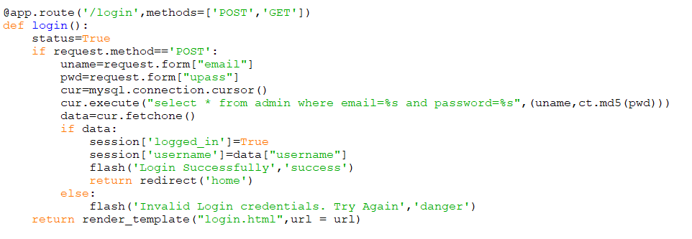
Registration
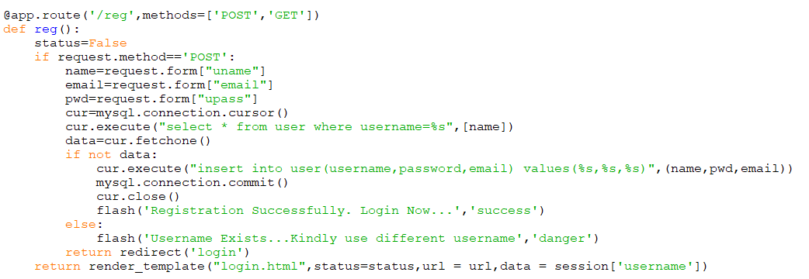

Prediction
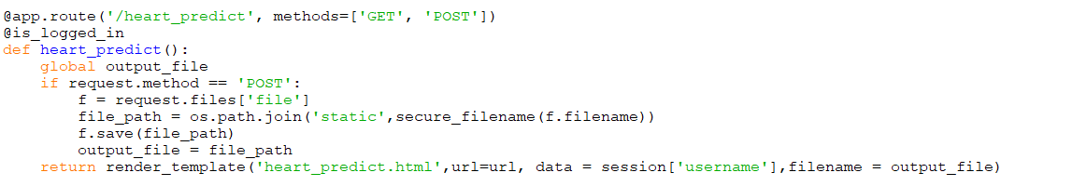

Chapter 6

SNAP SHOTS
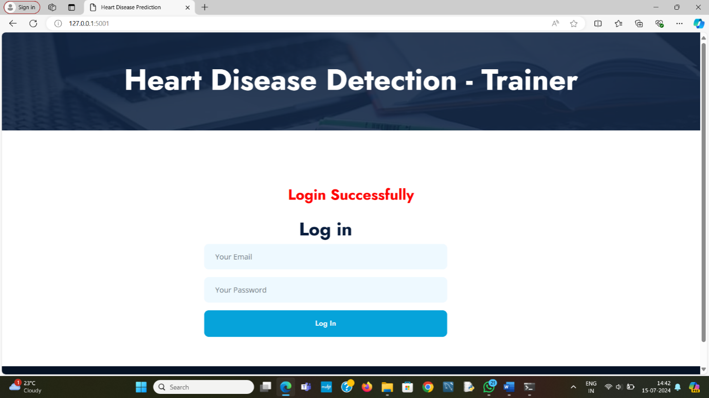

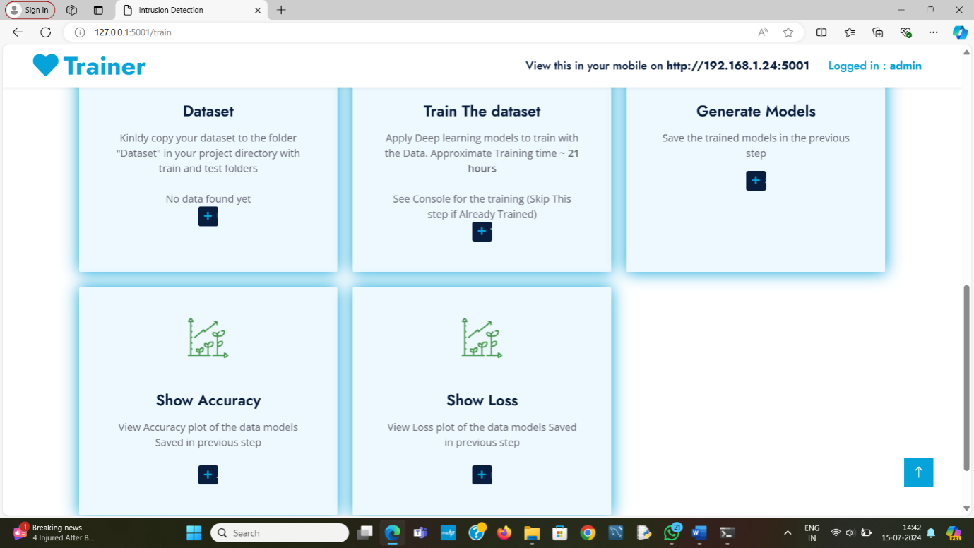
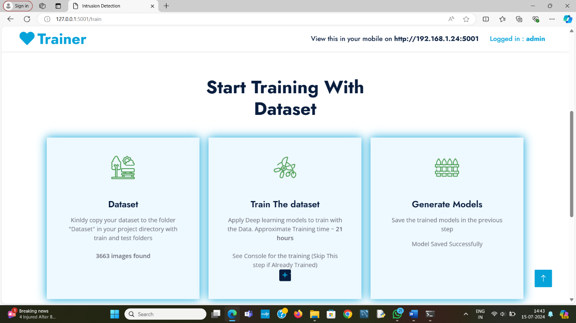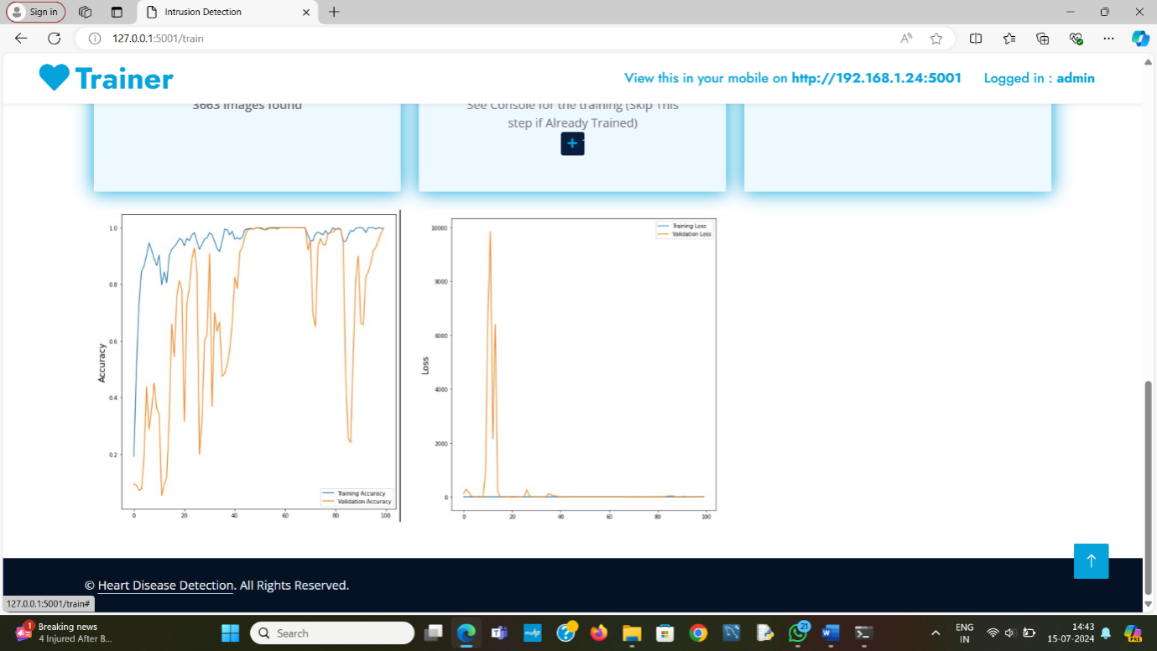
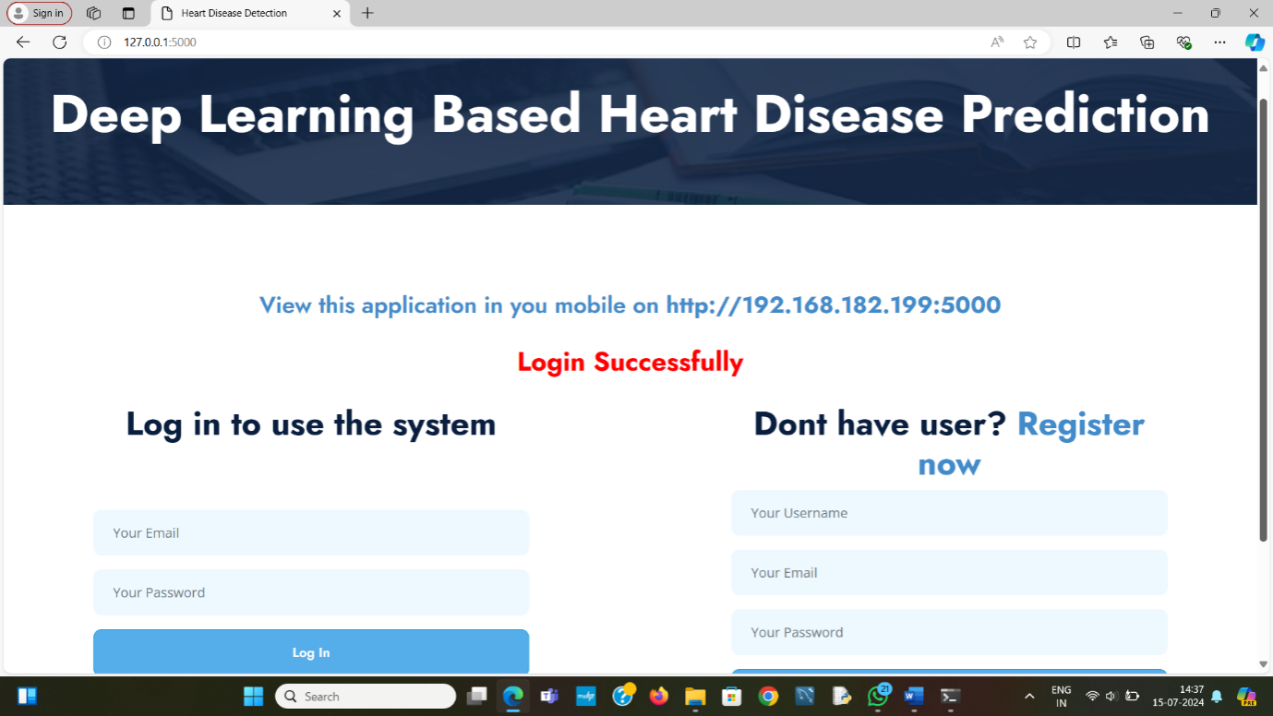

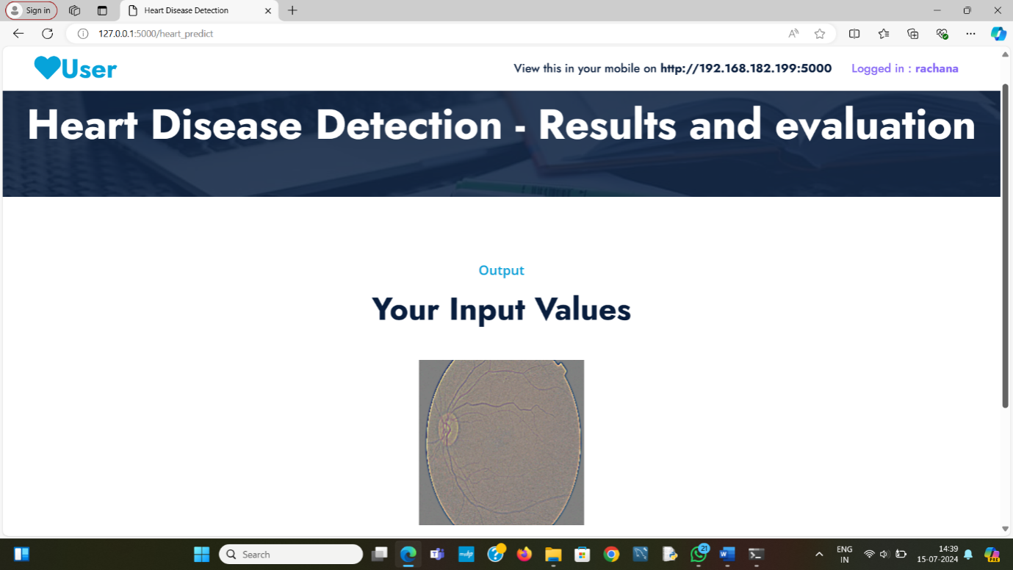
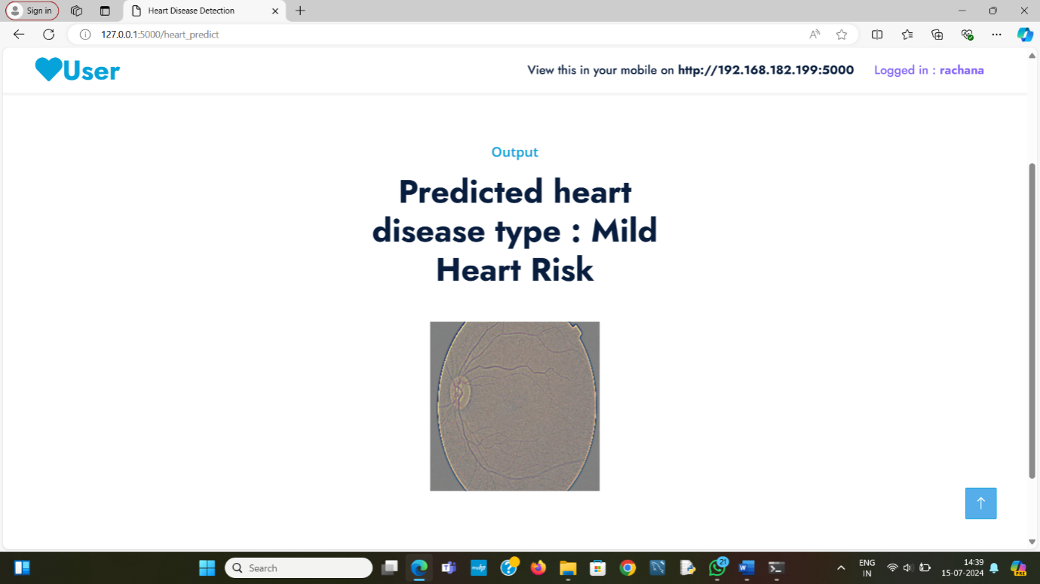

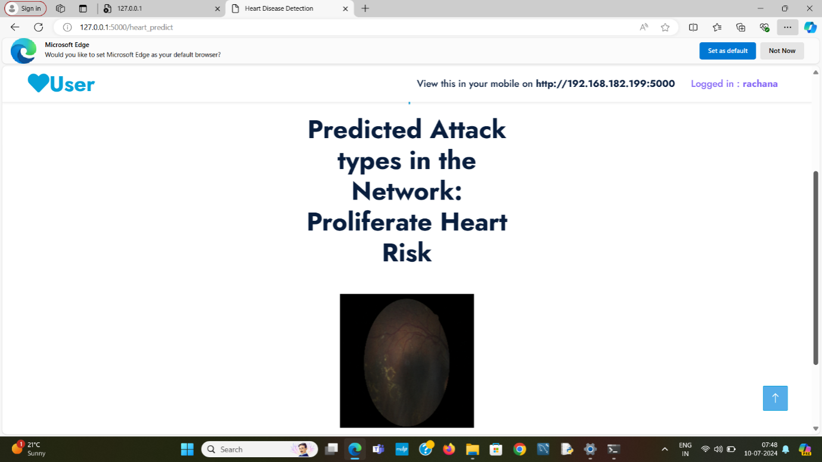

Chapter 7

SOFTWARE TESTING

INTRODUCTION

Software testing is a process of executing a program or application with the intent of finding the software bugs.

Software testing is a critical element of software quality assurance and represents the ultimate process to ensure the correctness of the product. The quality product always enhances the customer confidence in using the product thereby increasing the business economics. In other words, a good quality product means zero defects, which is derived from a better quality process in testing.

Testing the product means adding value to it by raising the quality or reliability of the product. Raising the reliability of the product means finding and removing errors. Hence one should not test a product to show that it works; rather, one should start with the assumption that the program contains errors and then test the program to find as many of the errors as possible.

The main objective of testing is to find defects in requirements, design, documentation, and code as early as possible. The test process should be such that the software product that will be delivered to the customer is defect less. All Tests should be traceable to customer requirements. Test cases must be written for invalid and unexpected, as well as for valid and expected input conditions.
A necessary part of a test case is a definition of the expected output or result. A good test case is one that has high probability of detecting an as-yet undiscovered error.
Manual Testing
Manual testing includes testing a software manually, i.e., without using any automated tool or any script. In this type, the tester takes over the role of an end-user and tests the software to identify any unexpected behavior or bug. There are different stages for manual testing such as unit testing, integration testing, system testing, and user acceptance testing.

Testers use test plans, test cases, or test scenarios to test a software to ensure the completeness of testing. Manual testing also includes exploratory testing, as testers explore the software to identify errors in it.

Different stages for manual testing:

Unit Testing
This type of testing is performed by developers before the setup is handed over to the testing team to formally execute the test cases. Unit testing is performed by the respective developers on the individual units of source code assigned areas. The developers use test data that is different from the test data of the quality assurance team.

Tests that are performed during the unit testing in app are explained below:

1) Module Interface test: In module interface test, it is checked whether the information is properly flowing in to the program unit (or module) and properly happen out of it or not.

2) Boundary conditions: It is observed that much software often fails at boundary related conditions. That’s why boundary related conditions are always tested to make safe that the program is properly working at its boundary condition’s.

E.g. In case of if...else if... else... construct all the conditions are checked in the app. In case of loops, it is checked to see that the loops are not infinite and terminate once the condition becomes false.

3) Error handling paths: These are tested to review if errors are handled properly.

Integration Testing
Integration testing is defined as the testing of combined parts of an application to determine if they function correctly. Integration testing can be done in two ways: Bottom-up integration testing and Top-down integration testing. In this project we have followed the Bottom-up integration method.

Here testing begins with unit testing, followed by tests of progressively higher-level combinations of units called modules or builds.

Once all the different modules were integrated in the app, the app was tested for the following:

- Transition from one screen to another

System Testing
System testing tests the system as a whole. Once all the components are integrated, the application as a whole is tested rigorously to see that it meets the specified Quality Standards.

The features were tested rigorously for all possible inputs. Different test cases were executed to see if the app behaved as executed and there were no crashes and unexpected behavior.

Test Cases

TC  01 | Data  Collection | To import data from location | Import from file location | Valid location and file name | import data successful | Import data successful | Pass
 | Data  Collection | To import data from location | Import from file location | Invalid location and file name | Import data unsuccessful | Import data unsuccessful | Pass
TC  02 | Data pre-processing | To verify that data has pre-processed | Enter the data file imported | Valid detail | pre-processing successfully | pre-processing successfully | Pass
 | Data pre-processing | To verify that data has pre-processed | If invalid data file imported | Invalid detail | Pre-processing unsuccessfully | Pre-processing unsuccessfully | Pass
TC  03 | Train the data | To train data | Implement algorithms | Success output | Training successful | Training successful | Pass
TC  04 | Detection | Test the trained algorithm | Implement best algorithm to dataset | Success output | Prediction successful | Prediction successful | Pass
Chapter 8
CONCLUSION

In conclusion, Recurrent Neural Networks (RNNs) represent a powerful class of neural networks specifically designed for handling sequential data. Their ability to capture temporal dependencies and maintain memory over sequences makes them well-suited for a variety of applications, including the analysis of retinal images for heart disease detection. In the context of cardiovascular health, RNNs can be applied to sequential data derived from medical imaging, time-series physiological measurements, or other relevant sources. In the realm of heart disease detection from retinal images, the application of RNNs opens new possibilities for accurate and dynamic assessments, facilitating early diagnosis and personalized interventions. Continued research and development in this area, coupled with advancements in machine learning techniques, are likely to contribute significantly to the improvement of cardiovascular healthcare outcomes.

Chapter 8
FUTURE ENHANCEMENTS

Integrate additional modalities of data, such as patient demographics, clinical history, genetic information, or other medical imaging modalities like echocardiography or MRI scans. Fusion of multi-modal data can provide a more comprehensive view of cardiovascular health and improve the accuracy of disease detection.
BIBLIOGRAPHY

- Adler ED, Voors AA, Klein L, Macheret F, Braun OO, Urey MA et al (2020) Improving risk prediction in heart failure using machine learning. Eur J Heart Fail 22(1):139–147. https://doi.org/10.1002/EJHF.1628
- Akbilgic O, Butler L, Karabayir I, Chang P, Kitzman D, Alonso A et al (2021) Artificial intelligence applied to ecg improves heart failure prediction accuracy. J Am Coll Cardiol 77(18):3045. https://doi.org/10.1016/S0735-1097(21)04400-4
- Albert KF, John R, Divyang P, Saleem T, Kevin MT, Carolyn JP et al (2019) Machine learning prediction of response to cardiac resynchronization therapy: improvement versus current guidelines. Circ Arrhythmia Electrophysiol, vol 12(7). https://doi.org/10.1161/CIRCEP.119.007316
- Ali MM, Paul BK, Ahmed K, Bui FM, Quinn JMW, Moni MA (2021) Heart disease prediction using supervised machine learning algorithms: performance analysis and comparison. Comput Biol Med 136:104672. https://doi.org/10.1016/J.COMPBIOMED.2021.104672
- Araujo M, Pope L, Still S, Yannone C (2021) Prediction of heart disease with machine learning techniques. Graduate Res, Kennesaw State Un
- Breiman L (2001) Random forests. Mach Learn 45(1):5–32. https://doi.org/10.1023/A:1010933404324
- Caruana R, Karampatziakis N, Yessenalina A (2008) An empirical evaluation of supervised learning in high dimensions. In: Conference: machine learning, proceedings of the twenty-fifth international conference (ICML 2008), Helsinki, Finland
- Dalal S, Onyema EM, Kumar P, Maryann DC, Roselyn AO, Obichili MI (2022) A hybrid machine learning model for timely prediction of breast cancer. Int J Model Simul Sci Comput 0(0):2341023. https://doi.org/10.1142/S1793962323410234
- Diwakar M, Tripathi A, Joshi K, Memoria M, Singh P, Kumar N (2021) Latest trends on heart disease prediction using machine learning and image fusion. Mater Today: Proc 37(Part 2):3213–3218.

